Project Design Phase-II
Technology Stack (Architecture & Stack)
Date | 06/09/2026
Team ID | Servicenow
Project Name | Automated Network Request Management
Maximum Marks | 4 Marks

Technical Architecture:
The Deliverable shall include the architectural diagram as below and the information as per the table 1 & table 2.
Application: Automated Network Request Management
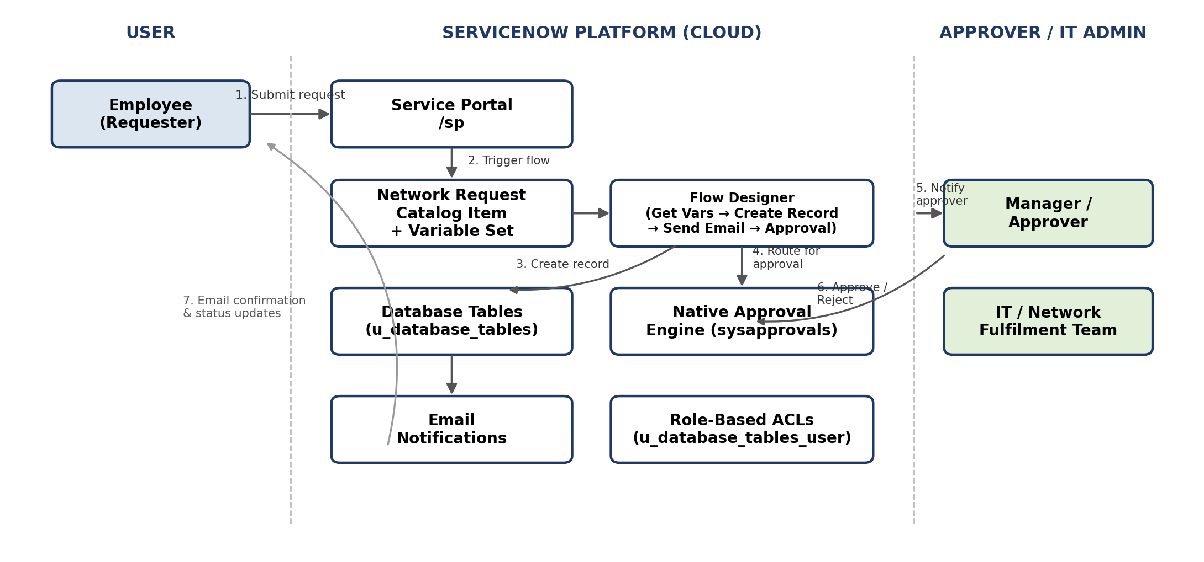
Table-1: Components & Technologies
S.No | Component | Description | Technology
1. | User Interface | How the user interacts with the application | ServiceNow Service Portal (Now Experience UI) — Network Request catalog item
2. | Application Logic-1 | Captures request data and creates the request record | Flow Designer — Get Catalog Variables, Create Record
3. | Application Logic-2 | Notifies requester of submission | Flow Designer — Send Email action
4. | Application Logic-3 | Routes the request for approval and branches on the outcome | Flow Designer — Ask for Approval, If / Else logic
5. | Database | Stores request data and field configuration | Custom ServiceNow table — Database Tables (u_database_tables)
6. | Cloud Database | Underlying platform database service | ServiceNow instance database (multi-tenant cloud, vendor-managed)
7. | File Storage | File storage requirements | Not applicable — no file attachments required for this request type
8. | External API | Purpose of external API used in the application | Not applicable — solution uses native ServiceNow capabilities only
9. | Machine Learning Model | Purpose of ML model, if any | Not applicable
10. | Infrastructure (Server / Cloud) | Application deployment | ServiceNow Personal Developer Instance (PDI), hosted on ServiceNow's cloud infrastructure

Table-2: Application Characteristics
S.No | Characteristics | Description | Technology
1. | Open-Source Frameworks | Frameworks used in the solution | None — built entirely on the proprietary ServiceNow platform (no custom scripting frameworks)
2. | Security Implementations | Security / access controls implemented | Role-based Access Control Lists (ACLs) scoped to the custom u_database_tables_user role
3. | Scalable Architecture | Justification of scalability | Built on ServiceNow's multi-tenant SaaS architecture; new catalog items and flows can be added without re-architecting
4. | Availability | Justification of application availability | Inherits ServiceNow's platform-level high availability and vendor-managed uptime SLAs
5. | Performance | Design considerations for performance | Native platform indexing and caching; Flow Designer executes asynchronously to avoid blocking user submissions

References:
https://c4model.com/
https://developer.ibm.com/patterns/online-order-processing-system-during-pandemic/
https://www.ibm.com/cloud/architecture
https://aws.amazon.com/architecture
https://medium.com/the-internal-startup/how-to-draw-useful-technical-architecture-diagrams-2d20c9fda90d

